C.V.

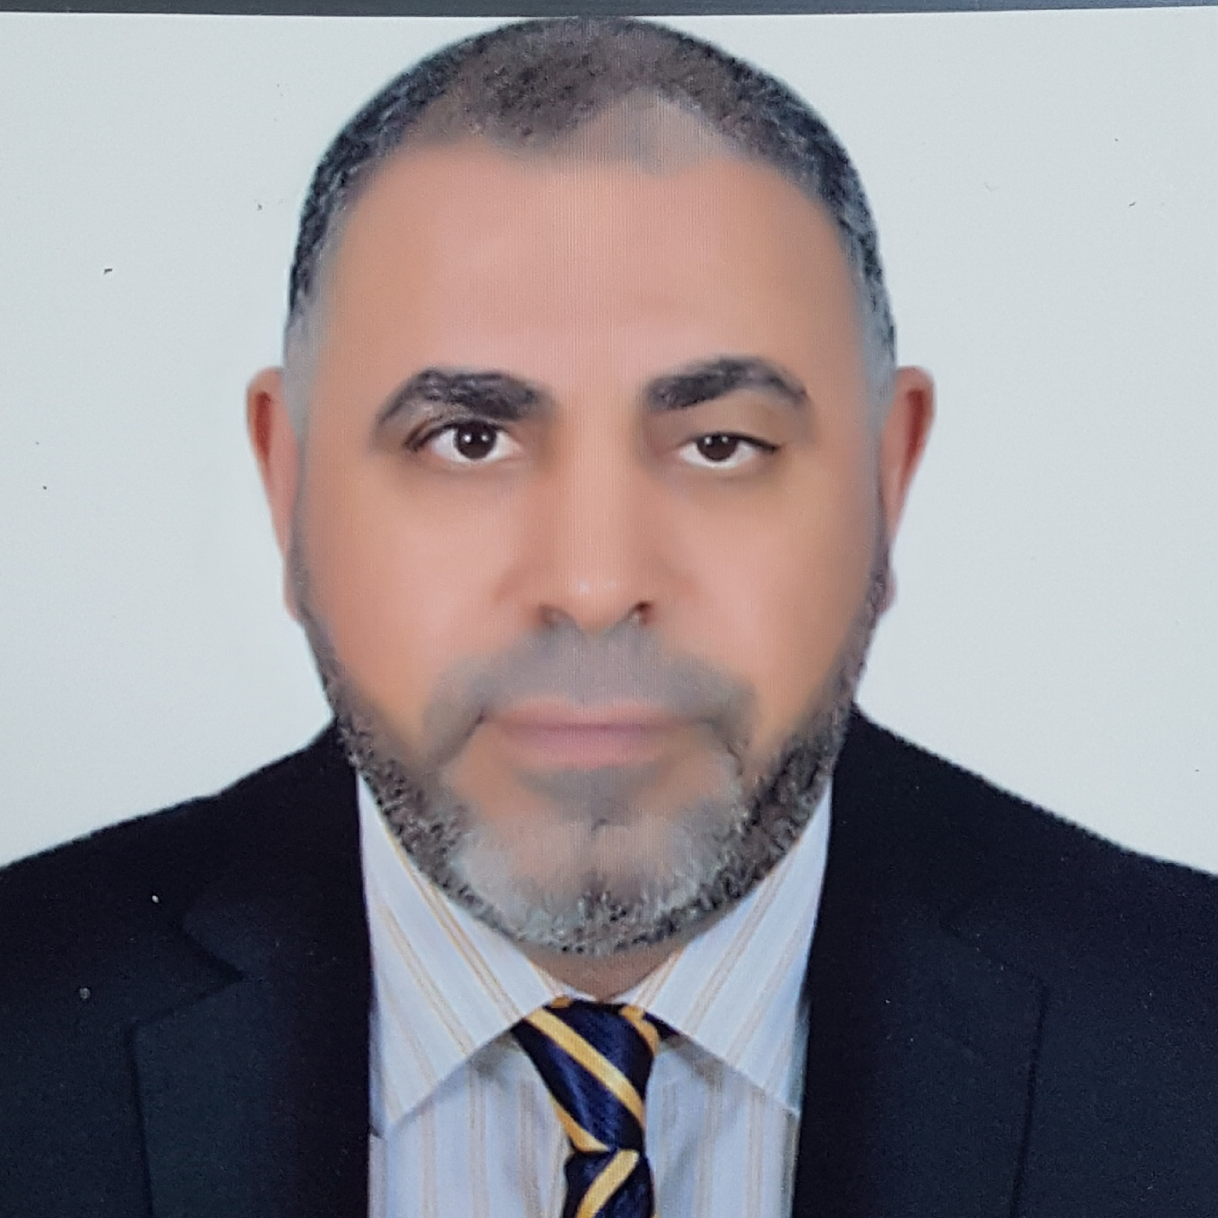
Personal Data:
Name : Osama Hussein Abdelsalam Alkady.
Date of birth : 4 -5 - 1971.
Nationality : Egyptian.
Marital status : Married + 3 sons and one daughter
Telephone No. : Home +20242144645
Mobile +201001916062
Email : oselfady452003@yahoo.com
Address:
Work : Benha university hospital –Dermatology and Andrology department – Benha- Egypt.
Home: Qualyoub –Alqualyoubia- Egypt.

Qualifications:
- MB.B.ch. December 1994, Benha faculty of medicine, Zagazig university with general grade of
excellent (distinction) with honor.
- Master degree in drematology and andrology, November 1999, Benha faculty of medicine,
Zagazig university with general grade of excellent (distinction).
- M.D. degree in drematology and andrology, November 2005, Benha faculty of medicine,
Zagazig university.
- Diploma in general surgery 2011 Benha university.
Certified in Egypt to perform the surgical interventions in the field of dermatology and andrology : penile prothesis implantaion – Hair transplantation – threads – testicular biopsy –
varicocelectomy – dermatologic surgery.
- Laser training course (30 hours) at medical laser center National Institute of Laser Enhanced
Sciences (NILES)

Job Experiences:
- House officer in Benha university hospitals (1-3-1995 to 29-2 1996).
- Training for primary health care (March, 1996).
- General practitioner at Qualyoub primary health care unit (1-4-1996 to 11-8-1996).
- Resident in Benha university hospitals-Dermatology and Andrology department
(12-8-1996 to 11-10- 1999).
5- Assistant lecturer of Dermatology and Andrology - Benha faculty of medicine - Benha university
hospitals - (8-1-2001 to 26-3-2006).
6- Lecturer of Dermatology and Andrology - Benha faculty of medicine - Benha university hospitals
( 27-3-2006 to 4-12-2017).
7- Assistant professor of Dermatology and Andrology - Benha faculty of medicine - Benha university
hospitals (5-12-2017 till 2024).
8- Consultant of Dermatology and Andrology , Nasser Institute For Research and Treatment – dermatology clinic - Cairo – Egypt (August 2006 till now).
9.professor of Dermatology and Andrology – Benha faculty of medicine – Benha university hospital (2024 till now )

Training courses:
Computer skills (Word, Power point , Internet).
Training courses for Benha university staff.

Researches:
1-Effects of cigarette smoking on human semen quality and α1,4-glucosidase activity as a marker of epididymal function. (Master thesis).
2-Effect of oxytocin treatment on semen quality in severe male factor infertility. (M.D.thesis).
3- Assessment of some systemic affection in psoriatic patients.
4- Role of scrotal duplex ultrasonography vs physical examination in the screening for varicocele in adolescents.
5-Different Trichoscopic Features of Tinea Capitis and Alopecia Areata in Pediatric Patients
6-Markers of inflammation and thrombophilia in psoriasis
7-Apoptotic markers in spongiotic dermatitis
8-CD30+ cells in benign inflammatory infiltrate of some dermatological diseases
9-Efficacy of Intralesional 5-Fluorouracil versus BCG Vaccine in the Treatment of Warts
10-Real-time PCR: A rapid and sensitive method for diagnosis of dermatophyte induced onychomycosis,
a comparative study
11-Blue light therapy versus low dose isotretinon in mild to moderate acne

Practical experiences

DERMATOLOGY
Laser hair removal
Fractional laser for rejuvination
Botox injection
Fillers injection
Platlet rich plasma injection (PRP)
Mesotherapy
Threads
Dermapen treatment for rejuvination

ANDROLOGY
Male infertility management
Testicular biopsy ( surgical and FNA)
Varicocelectomy
Erectile dysfunction management
Penile prothesis implantation
Sexually transmitted diseases management
Languages
Arabic and English.
TOEFL test June 2000 , score 553, Ain Shams University Centre for Developing English Language Teaching.

Conferences
Attendant of conferences of Egyptian soceities of dermatology and andrology.
Attendant of Jeddah Dermatology and Cosmetic Conference 2013-2014 and Dubai derma 2013-2014.
Attendant of EADV Amsterdam October 2014
Attendant of EADV Spring symposium Valencia May 2015
Attendant of 23RD WCD Vancouver – Canada June 2015
Attendant of EADV Copenhagen 2015
Attendant of AAD Washington D.C March 2016
Attendant of EADV Vienna September 2016

Speaker and member of the organizing committee of the 3rd, 4th, 5th , 6th , 7th and 8th annual meeting of the Dermatology and Andrology department - Benha faculty of medicine,Benha university.
(May 2005 – 2006 -2007, 2008, 2009 and 2012 Helnan Port Said-and Alexandria Egypt).
Speaker in 22nd Congress of The Egyptian Society of Andrology 22nd – 24th December, 2011 Ain El-Sukhna Egypt.

Talks:
Methotrexate versus neo biologics in treatment of psoriasis. (May 2005)
G-spot and female ejaculation. (May 2005)--Evidence based medicine. (May 2006)
Ozone therapy. (May 2006)--Quality of life (May 2007) ) – cost benefit (2008)
Stem cell.(May 2009)
External genital warts (December , 2011)
Matter of debate (May 2012)
Media: Guest on Albaraka T.V, Alrahmah T.V, 3rd channel and Sehaty T.V in medical programs.

References
- Prof. Abdelaziz Eltaweel, professor and head of the department of dermatology and andrology, Faculty of medicine, Benha university, Egypt.

- Prof. Mahmoud Elbayoumi, professor of dermatology and andrology, Faculty of medicine, Benha university, Egypt.

- Prof. Khaled Mohiey El-Din Monieb, professor of dermatology and andrology, Faculty of medicine, Benha university, Egypt.

- Prof. Samy Hanafy Mohammed, professor of dermatology and andrology, Faculty of medicine, Benha university, Egypt.

- Prof. Mohammed Kenawy, professor and head of the department of dermatology and andrology, Faculty of medicine, Benha university, Egypt.

- Prof. Hatem Abu-El-Wafa Zohdy, professor of dermatology and andrology, Faculty of medicine,
Benha university, Egypt.

- Prof. Assem Mohammed Farag, professor of dermatology and andrology, Faculty of medicine, Benha university, Egypt.

- Prof. Ihab Younis, professor of dermatology and andrology, Faculty of medicine,
Benha university, Egypt.

- Naser Institute for Treatment and Research, Kornish el neel, Cairo, Egypt.

